**DAILY ONLINE ACTIVITIES SUMMARY**

|  |  |  |  |  |  |  |  |  |
| --- | --- | --- | --- | --- | --- | --- | --- | --- |
| **Date:** | **10/06/2020** | | | | | **Name:** | **PONICA.J** | |
| **Sem & Sec** | **4TH & B** | | | | | **USN:** | **4AL18CS055** | |
| **Online Test Summary** | | | | | | | | |
| **Subject** | | **OOC** | | | | | | |
| **Max. Marks** | | **30** | | **Score** | | | **18** | |
| **Certification Course Summary** | | | | | | | | |
| **Course** | **THE FUNDAMENTALS OF DIGITAL MARKETING** | | | | | | | |
| **Certificate Provider** | | | **GOOGLE DIGITAL**  **UNLOCKED** | | **Duration** | | | **40HOURS** |
| **Coding Challenges** | | | | | | | | |
| **Problem Statement:** Write a Java Program to find total number of subarrays which start and end with the same element | | | | | | | | |
| **Status:EXECUTED** | | | | | | | | |
| **Uploaded the report in Github** | | | | | **YES** | | | |
| **If yes Repository nameO** | | | | | **https://github.com/ponica-jaya/LOCKDOWN-CODING.git** | | | |
| **Uploaded the report in slack** | | | | | **YES** | | | |

Online Test Details: (Attach the snapshot and briefly write the report for the same)

TODAY I HAD TEST ON THE SUBJECT OOC FROM 9.15 AM TO 9.40AM

TOTALLY WE HAD 15 CODING MCQ QUESTIONS EACH CARRIES OF 2MARKS AND I HAVE ATTENDED THE TEST AND I HAVE ATTACHED THE SNAPSHOT OF IT BELOW.

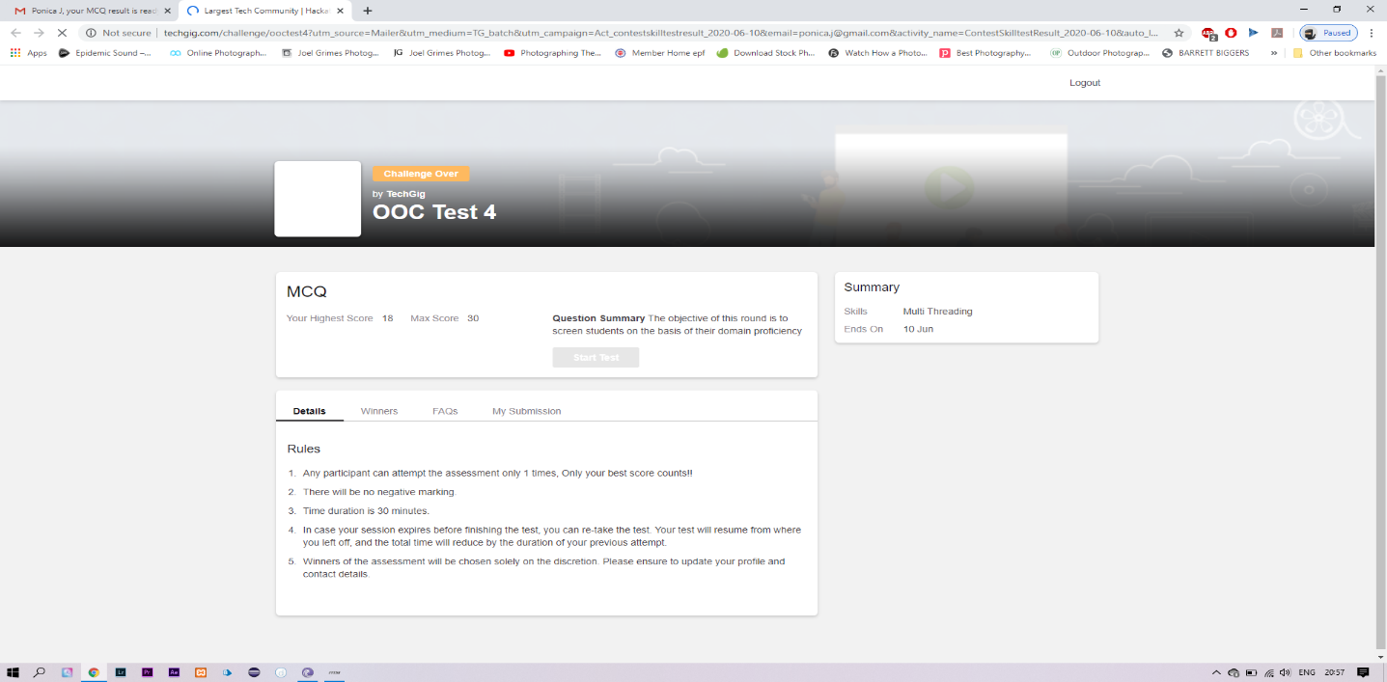

Certification Course Details: (Attach the snapshot and briefly write the report for the same)

TODAY I HAVE COMPLETED THE FUNDAMENTALS OF DIGITAL MARKETING COURSE PROVIDED BY GOOGLE DIGITAL UNLOCKED FOR 40 HOURS AND I HAVE GOT MY CERTIFICATE TOO.

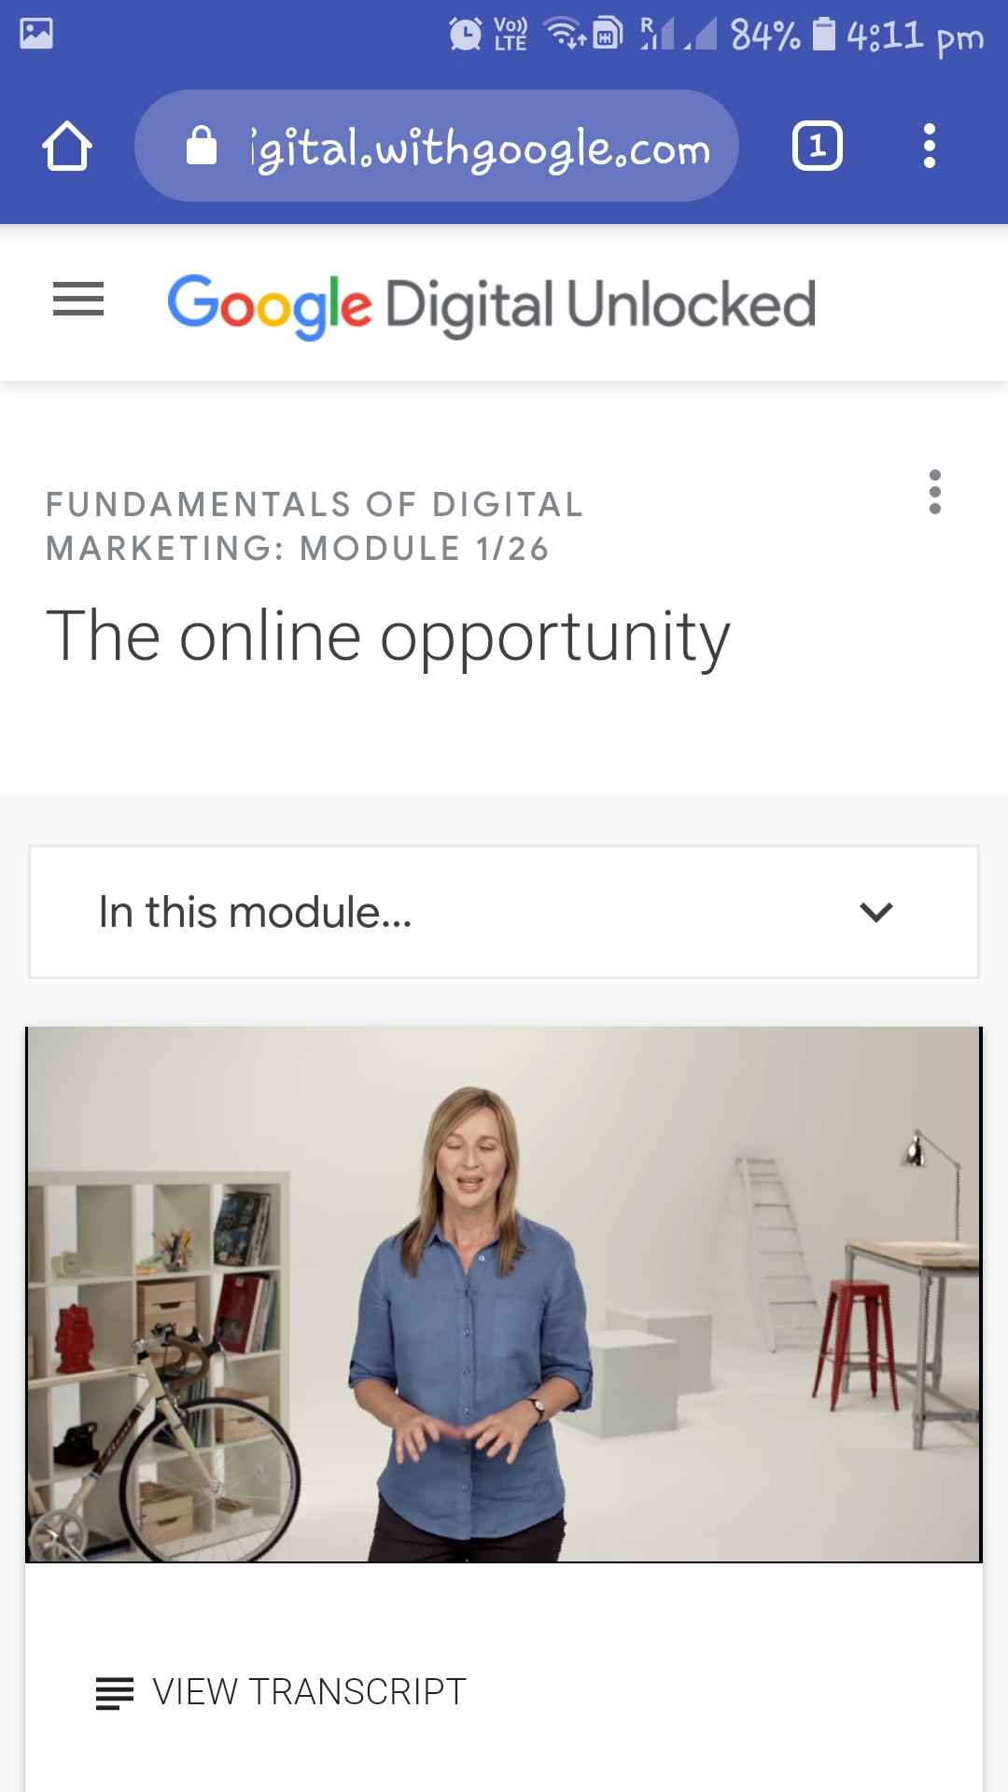

Coding Challenges Details: (Attach the snapshot and briefly write the report for the same)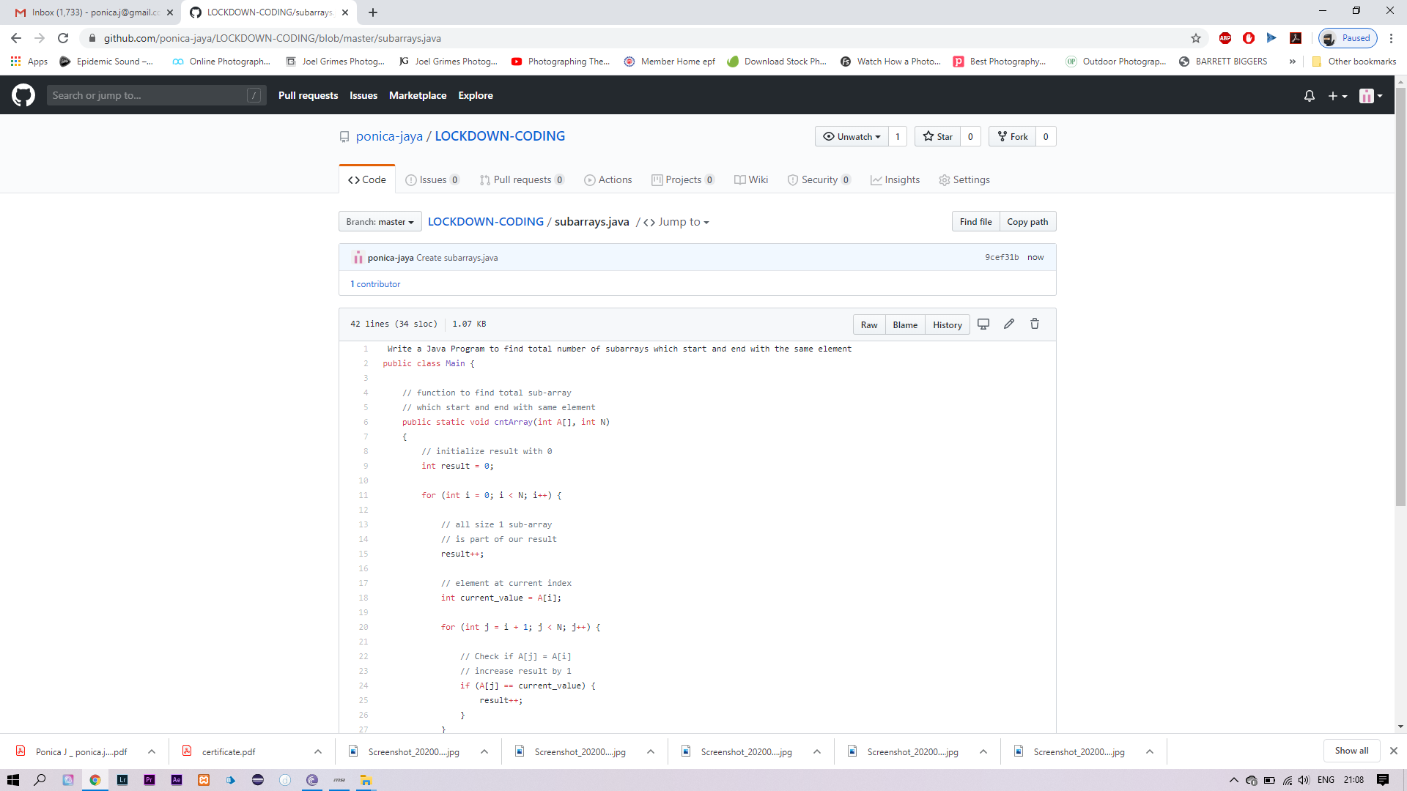

TODAY I HAVE RECEIVED AN MAIL FROM MY TEACHERS AND THEN I HAVE SOLVED THE SOLUTION AND THEN UPLOADED IN MY GITHUB ACCOUNT.